**Hackathon Day3**

*API Integration and Migration Report:*

*Sanity CMS Schema:*

*Sanity Schema defines the structure and field for content in a sanity CMS. It allows to create custom document types like food and chef to organize and manage data efficiently….*

*Food.ts:*

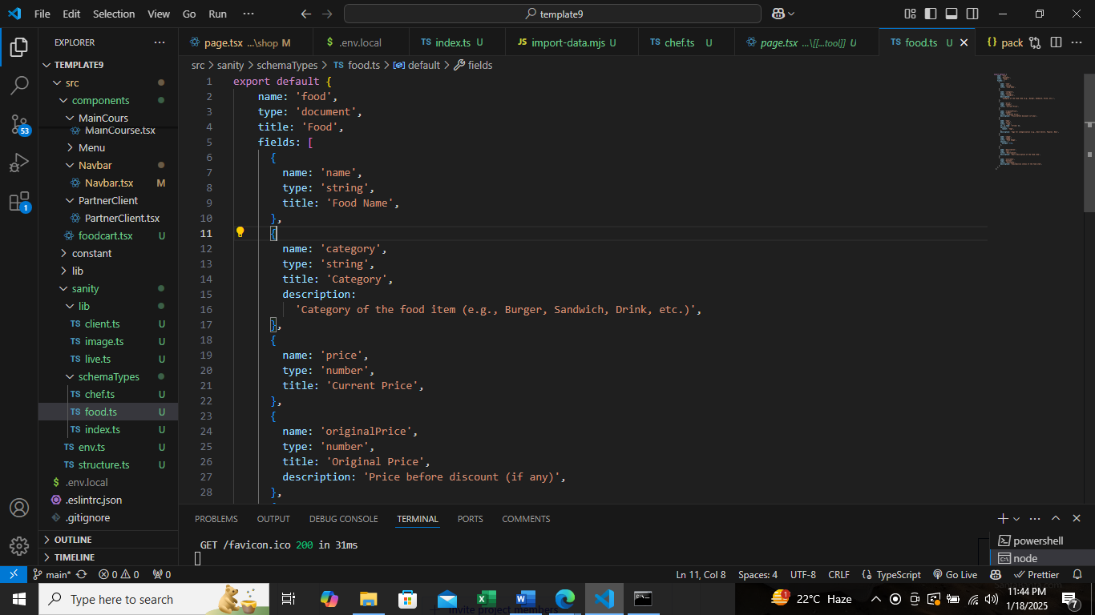

Chef.ts:

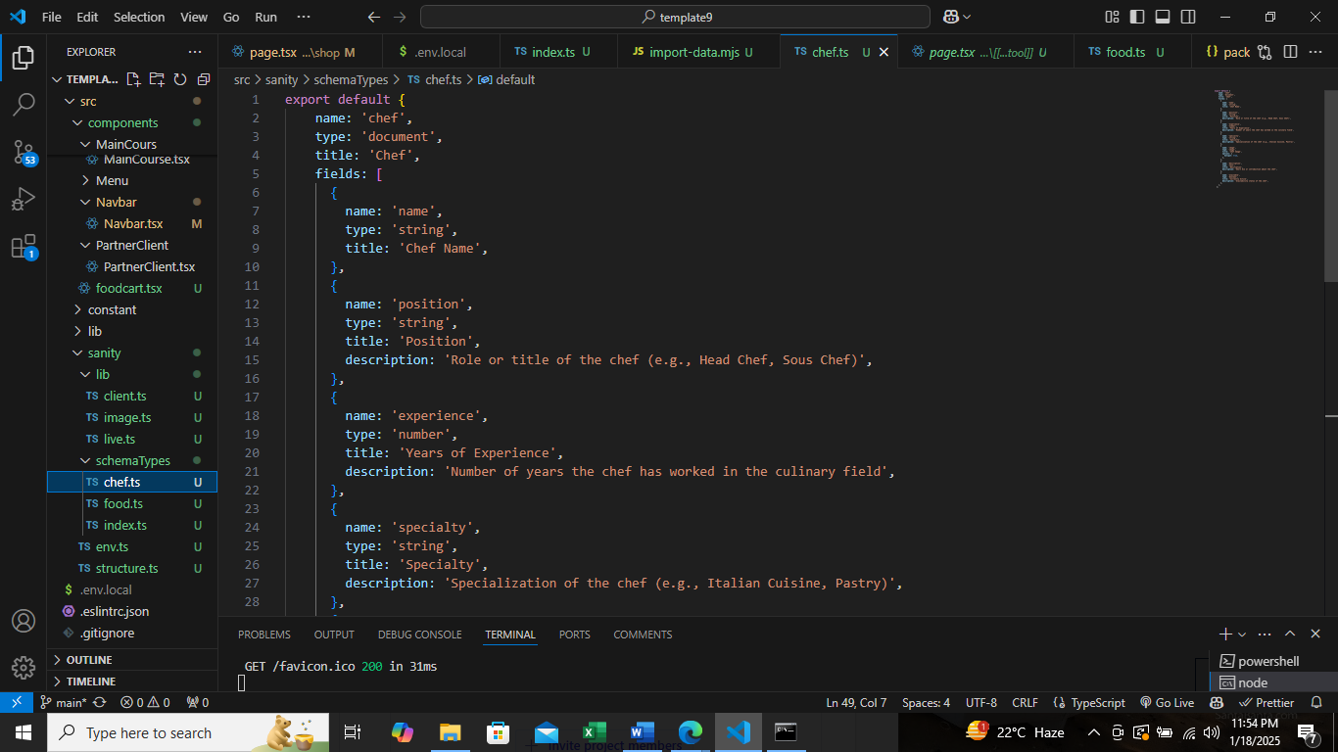

API Data Fetching:

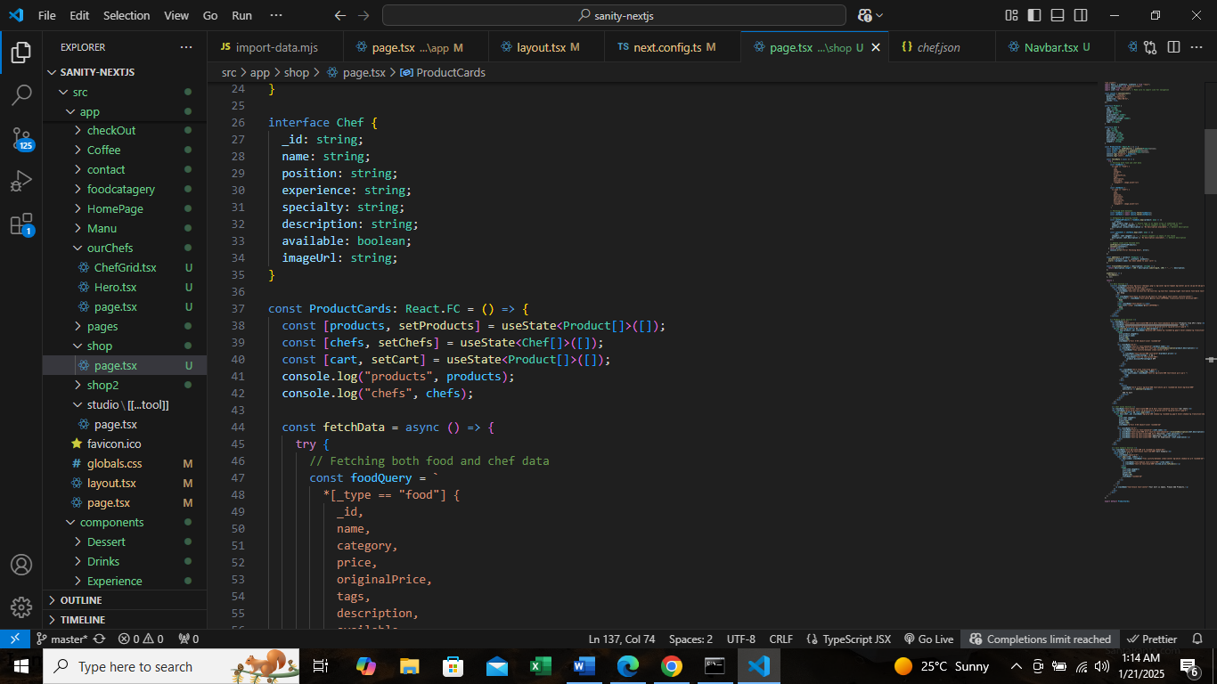

Data Migration:

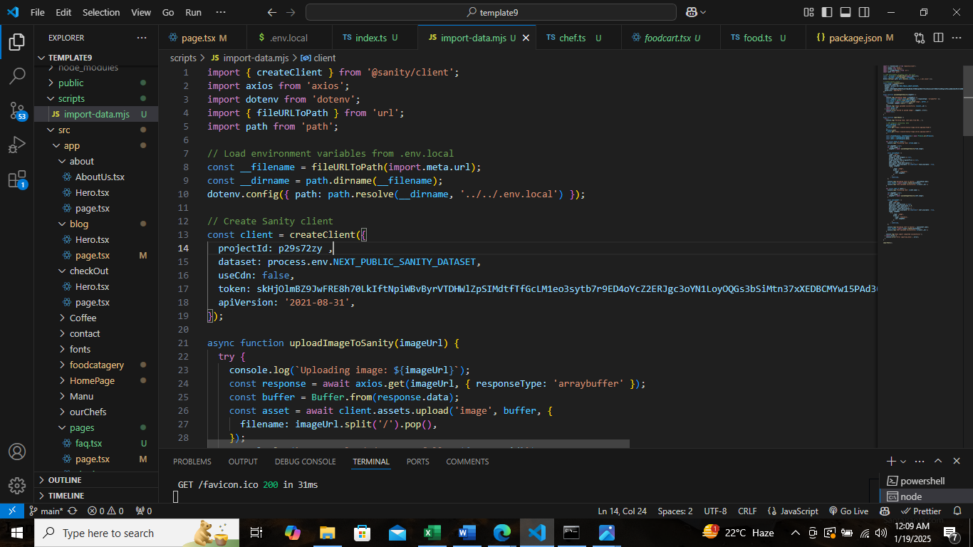

Sanity Studio:

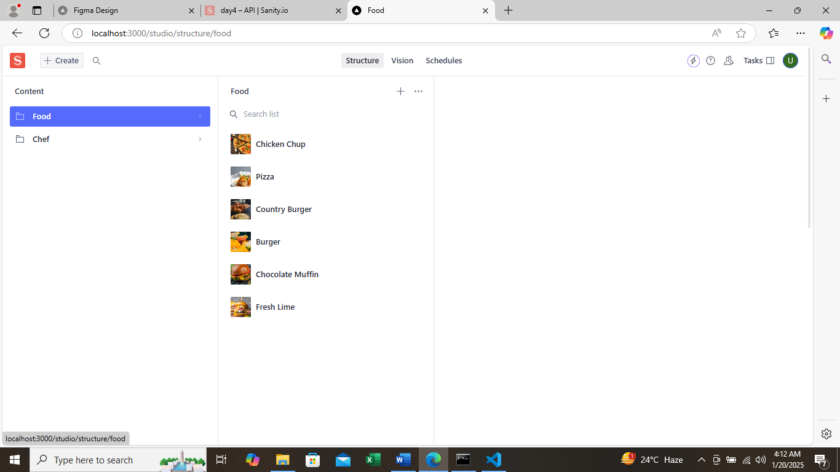

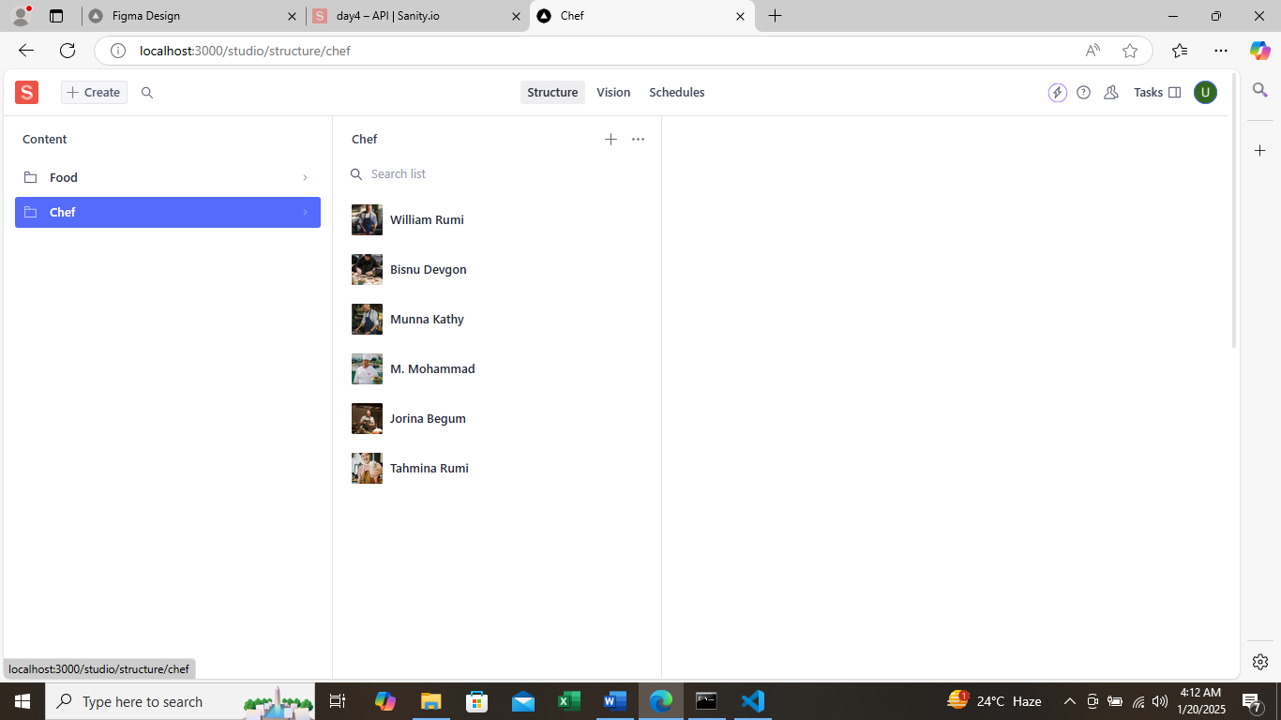

Sanity Vision:

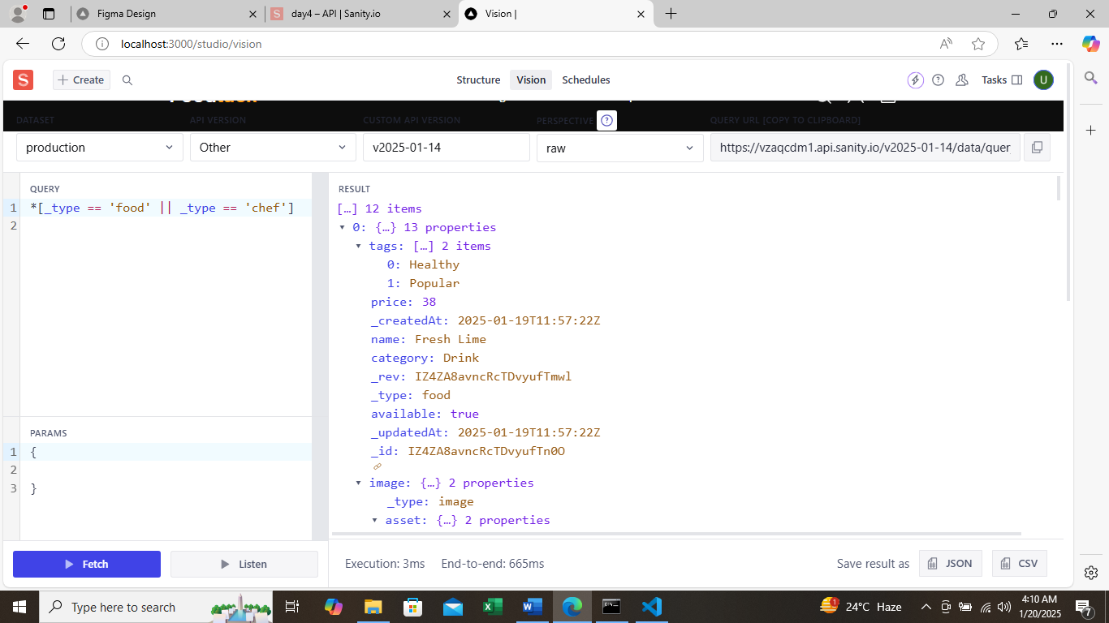

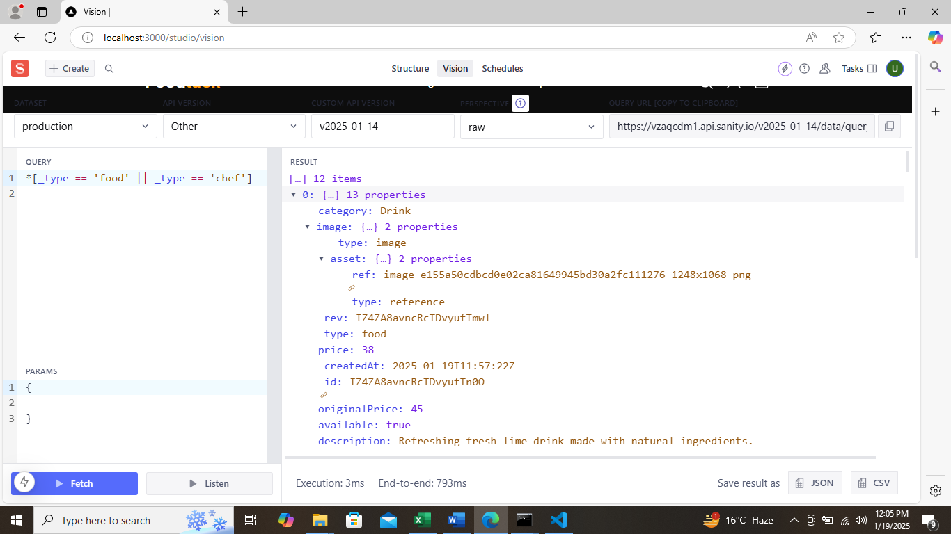

Sanity DataBase:

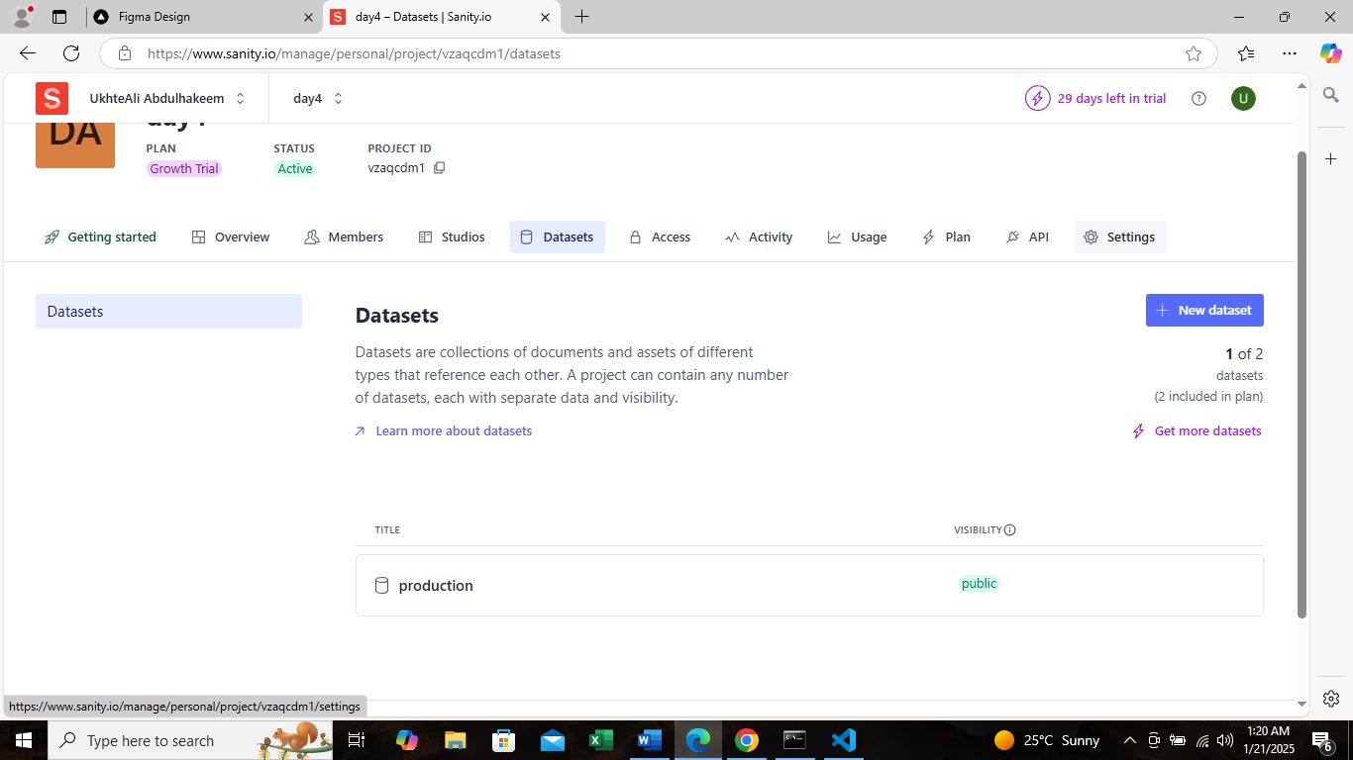

Product Detail page:

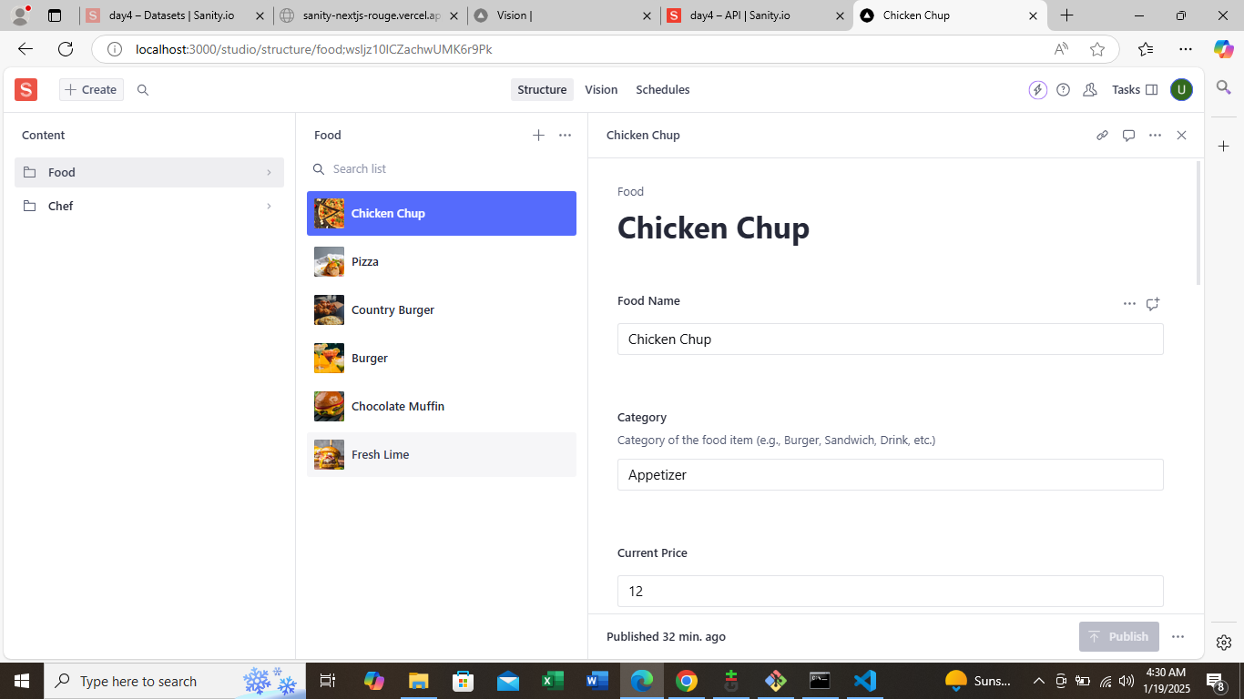

Conclusion:

The API Integration and migration were successfully completed,improving the efficiency and scalability of the food tuck website.This integration simplified the process of udating food items, while migration ensured data accuracy across the system.